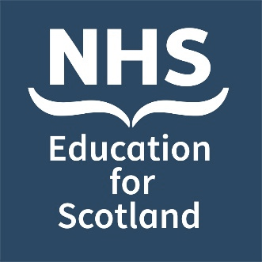
Date: Thursday 24 November 2022

NES Bereavement Education Conference 2022
Call for Poster Abstracts & Submission Form
Venue: Virtual

Invitation: You are invited to submit poster abstracts for the NHS Education for Scotland (NES) virtual bereavement education conference:

Exploring bereavement from a new perspective

#NESBereavement2022

NES is very pleased to be hosting its third bereavement education conference on 24 November 2022. This one-day virtual event will be relevant to all health and social care professionals.

Poster categories: We invite submissions of posters covering any aspect of innovation and creativity leading to improved outcomes for those who are bereaved. These may include aspects of education, service delivery and quality improvement relevant across a wide spectrum of bereavement related situations. We are also happy to accept work that has already been presented at other events.

We encourage the lead / nominated author of each successful abstract to attend the virtual event. Further details will be forwarded to authors of successful abstracts in due course.

Abstract template: Please use the abstract template on the following page to complete your submission and send it to events@nes.scot.nhs.uk

Key dates:

Deadline for poster abstract submissions | Extended to Monday 10 October at 12 noon
Lead authors will be notified whether their abstract has been selected | Monday 17 October

Should you have any queries or would like further information:

- Email: events@nes.scot.nhs.uk

Please note successful abstract submissions will have their poster published on the virtual e-poster conference platform, on the NES Support Around Death website and they may also be posted on our Social Media Channels.
Please tick to confirm you have read the above and agree to your poster being published:

Title of Poster Abstract:
Name of lead author:
Email of lead author:
(Please provide a work email address where possible)

Affiliation/ institution of lead author:
Name(s) of co-author(s):
Institution(s) where work was carried out:

Abstract text (300-word limit) – you may find it useful to utilise the following structure (Introduction, Methods, Results / Discussion, Conclusion) but this is not mandatory.

