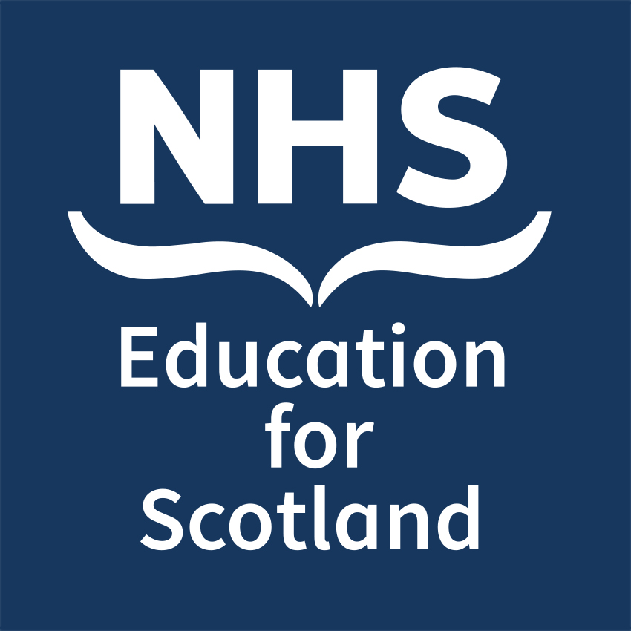

Title
Sub-title

Refocusing District and General Practice Nursing
Roles in Integrated Adult Community Nursing
Teams: New Approaches to Education
Call for Poster Abstracts

NHS Education for Scotland (NES) is inviting abstracts for a poster presentation at our 2018 Conference: Refocusing District and General Practice Nursing Roles in Integrated Adult Community Nursing Teams: New Approaches to Education on 1 November at Murrayfield Stadium, Edinburgh.

This is an opportunity to share innovative district and general practice nursing achievements and educational initiatives supporting the Transforming Roles Programme, maximizing the contribution of the nursing workforce and pushing the traditional boundaries of professional roles to meet the current and future needs of Scotland’s health and care system.

Timeline for submissions:
Deadline for receipt of abstract submissions: Friday 28 September
Outcome of selection panel communicated to abstract leads: Tuesday 2 October (You will automatically secure a place at the conference if your abstract is selected)
Abstracts can be submitted under one of the following categories:

- Leadership and quality improvement _______
- Innovative approaches to learning _______

Title of Abstract:
Name of presenting author:
Job title of presenting author:
Email of presenting author:

Name(s) and job titles of co-author(s):
Institution/organisation where work carried out:
Short, clear and concise abstract text (200 word limit). Please use the following headings: Introduction, Methods, Results/Discussion, Conclusion, Relevant Links/ References

Please email your completed form to: events@nes.scot.nhs.uk no later than Friday 28 September

